Long-distance vocalizations of spotted hyenas contain individual, but not group, signatures

Kenna D. S. Lehmann, Frants H. Jensen, Andrew S. Gersick, Ariana Strandburg-Peshkin, and Kay E. Holekamp

2022-02-24

# 

# Abstract (limit 200 words)

In animal societies, identity signaling is crucial for mediating interactions within groups, and for discriminating against out-group competitors. However, individual recognition becomes increasingly challenging as group size increases and as signals have to be transmitted over greater distances. Group vocal signatures appear to evolve when successful in-group/out-group distinctions are at the crux of fitness-relevant decisions, but individual-based recognition systems may be demanded when relationships *within* groups require further decision-making. Spotted hyenas are social carnivores that live in stable clans of <125 individuals composed of multiple unrelated matrilines. Clan members cooperate to defend communal territories from neighboring clans and other mega carnivores, and this collective territory defense is mediated by long-range (up to 5 km range) recruitment vocalizations, called whoops. Here, we use machine learning to determine that spotted hyena whoops contain individual but not group signatures, and that fundamental frequency features that propagate well are critical for individual discrimination. Consequently, hyenas face the challenge of recognizing individual callers at long range to distinguish clan members from competitors. We show that serial redundancy in whoop bouts increases individual classification accuracy and thus extended call bouts used by hyenas likely evolved to overcome the challenges of communicating individual identity at great range.

## Key words

animal communication, long-distance signals, individual signatures, group signatures

# Introduction

Social animals use caller information embedded in signals to facilitate cooperation among group-members and identify and coordinate responses to out-group conspecifics. For effective communication, receivers need to detect species-specific signals embedded in noise (detection), parse information encoded in the signal (discrimination), and ultimately respond adaptively to the signal (response) ?[1]?. Discrimination of signals depends on how information is encoded in signals; how that information degrades during signal transmission; how the receiver auditory system can parse that information; and how the cognitive system interprets and classifies the perceived signal features according to either innate or learned representations.

The identity of the caller is important in large groups with both differentiated relationships within groups and competition among groups [2]. In such groups, individual recognition represents the basis of social cognition [3] because it is necessary for receivers to tailor their response to the current situation [4], including the identity of the signaling individual [2,5,6]. In such cases, signals should emphasize individually distinctive information [7]. For example, signature whistles in bottlenose dolphins are unique to individuals [8] and stable across decades [9], allowing male dolphins to form and maintain complicated multi-level cooperative relationships [10,11]. However, individual recognition becomes increasingly challenging as group size increases and as signals must be transmitted over greater distances.

As a social group grows, the larger signal set becomes more difficult to discriminate [12,13] and the amount of individual categorization required is compounded, possibly explaining why wolf howls include both group [14] and individual signatures [15]. In many species (e.g. chimpanzees [16], green wood hoopoes [17], orca whales [18,19] and sperm whales [20,21]) this results in one or more signals that encode information on the group-membership of the caller (i.e. “group signature”), either in the absence of, or in addition to individual identity signatures [7].

Thus, we expect group vocal signatures to evolve when groups are large, individuals communicate over long distances, and successful in-group/out-group distinctions are at the crux of fitness-relevant decisions, while individual recognition systems may be selected for when relationships *within* groups require further decision-making (e.g. relationships vary among group-mates or change quickly over time).

An additional problem arises when individual or group identity information must be transmitted over long distances. In such cases, information is predicted to be encoded in call features that are more robust to sound propagation. Therefore, long-distance acoustic signals should be tonal because pure tones travel better than broadband noise, which is susceptible to scattering [22]. Since attenuation due to refraction, scattering, and heat loss increases with frequency, calls optimized for long-range propagation are expected to be relatively low-frequency. Long-range propagation also leads to increased signal reverberation from reflections and refraction, favoring information encoded in frequency modulations rather than amplitude modulations [22,23]). As a result of these physical constraints, distinctive voice features that might allow for recognizing individuals at short range, such as subtle difference in formant spacing shaped by vocal tract filtration, are unlikely to be useful for long-range identification of callers.

*Should this paragraph be moved to the discussion? I worry about the repetition analysis coming out of nowhere if it isn’t discussed at all in the intro* To maximize detection and improve discrimination, signalers can increase amplitude, avoid noise either in time or signal space, or increase redundancy in a signal (summarized in [1]). Redundancy can be achieved in two ways: “degenerate signals” employ multiple modes to transmit the same or similar information in multiple sensory channels simultaneously while “redundant signals” are literally redundant via repetition [24,25]. However, long-distance communication is often restricted to the auditory channel, making multimodal signaling impossible and redundant signals advantageous. *note from Andy: Do you want to note that one of these (increasing amplitude) has a relatively low, physiologically determined ceiling, one (avoiding noise) is likely out of the signaler’s control, but the third (redundancy) is under behavioral control and probably ramps up at relatively low cost?*

Spotted hyenas are large carnivores that live in social groups, called ‘clans,’ which contain up to 125 members [26,27] that cooperate to defend a large communal territory against neighboring clans and other large carnivores (13-1095 km2, [26]). Each clan contains multiple unrelated matrilines of females and their offspring, as well as one or more immigrant males that sire most young [28]. Female hyenas are philopatric, but most males disperse from their natal clan to join a new clan at 2 to 6 years of age [29–32]. Each hyena clan is structured by a strict linear dominance hierarchy [33] where social rank determines priority of access to resources. Relationships among clan-mates thus vary based on rank, sex, age, and kinship. These dynamic relationships are further complicated by the fission-fusion nature of hyena clans [34,35]. While clan membership is largely stable over time, individuals and sub-groups break apart and come together many times during a day at myriad locations within the clan territory [36].

The long-distance call of spotted hyenas, the whoop vocalization, has multiple hypothesized functions [29], including recruitment and coordination of movements by clan-mates within their territory [37,38], sexual advertisement [39], finding specific group-mates [40], and territory maintenance [31,41].The whoop vocalization is loud and can be heard up to 5 km away [29,42]. It is most often emitted in bouts that range from 2 to 34 whoops [42] and each whoop is a harmonic, frequency modulated, tonal call. At least at short range, mothers recognize and respond strongly to the whoops of their young offspring [40] and individual distinctiveness in cub whoops appears to extend into adulthood [39]. The fundamental frequency of a whoop provides reliable information about the caller’s age class and, for adult callers, information about sex as well [38]. Thus, whoops appear to encode information about the caller’s age, sex, location, affective state, and individual identity.

To effectively defend their common territory, hyenas rely on long-distance communication to coordinate a large number of clan members dispersed over an expansive territory. Have hyenas, like wolves [14], evolved a group-specific label to simplify the cognitive challenge of identifying clan members at long range?

Here, we use machine learning to test whether the hyenas’ long-distance vocalizations contain group or individual signatures, and to identify call features that can facilitate discrimination. We then use these results to quantify how serial redundancy in extended whoop bouts can affect individual classification accuracy. Finally, we discuss the implications of these findings for understanding signal evolution and acoustic communication in large, socially complex, and spatially dispersed species.

# Methods

## Study animals and call recordings

We recorded whoops emitted by spotted hyenas from four clans monitored by the Mara Hyena Project in the Maasai Mara National Reserve, Kenya (Figure S1). We identified all members of each clan by their unique spot patterns, assigned birthdates (± 7 days) to natal animals based on cub appearance when first seen [43], and assigned a sex to each individual based on the shape of its erect phallus [44].

We obtained recordings of whoops in two ways (Figure S2). First, observers deployed recording equipment from the windows of off-roading vehicles used as mobile blinds. Second, custom-made sound-, movement-, and position-recording Tellus radio collars were deployed on five adult females from the Talek West clan (January to March 2017). Recording methods are indicated for each whoop in Table S1.

We isolated whoop bouts from both types of digital field recordings, noted the time, date, and identity of the calling hyena and matched this information with the age, sex, and clan membership of the caller. We then cut each whoop bout into single whoops for analysis (Figure 1), using only whoops from adult hyenas that were at least 24 months and thus reproductively mature hyenas [45] to eliminate the possibility that young hyenas might not yet have learned a potential group signature.

We classified whoops into four types (Figure 1a) based on a classification scheme modified from East and Hofer [42]. Preliminary whoops (P type) are often emitted at the beginning of the whoop bout and are typically very short relative to other whoops in the bout. Symmetric (S type) whoops resemble a flattened bell curve, with the peak frequency near the center of the call. In contrast, asymmetric (A type) whoops have a long constant frequency portion that rises to peak frequency toward the end of the call. Terminal (T type) whoops are often the last whoop in a bout. They maintain a relatively constant, low frequency, and are often of lower amplitude than the other whoops in the bout [39].

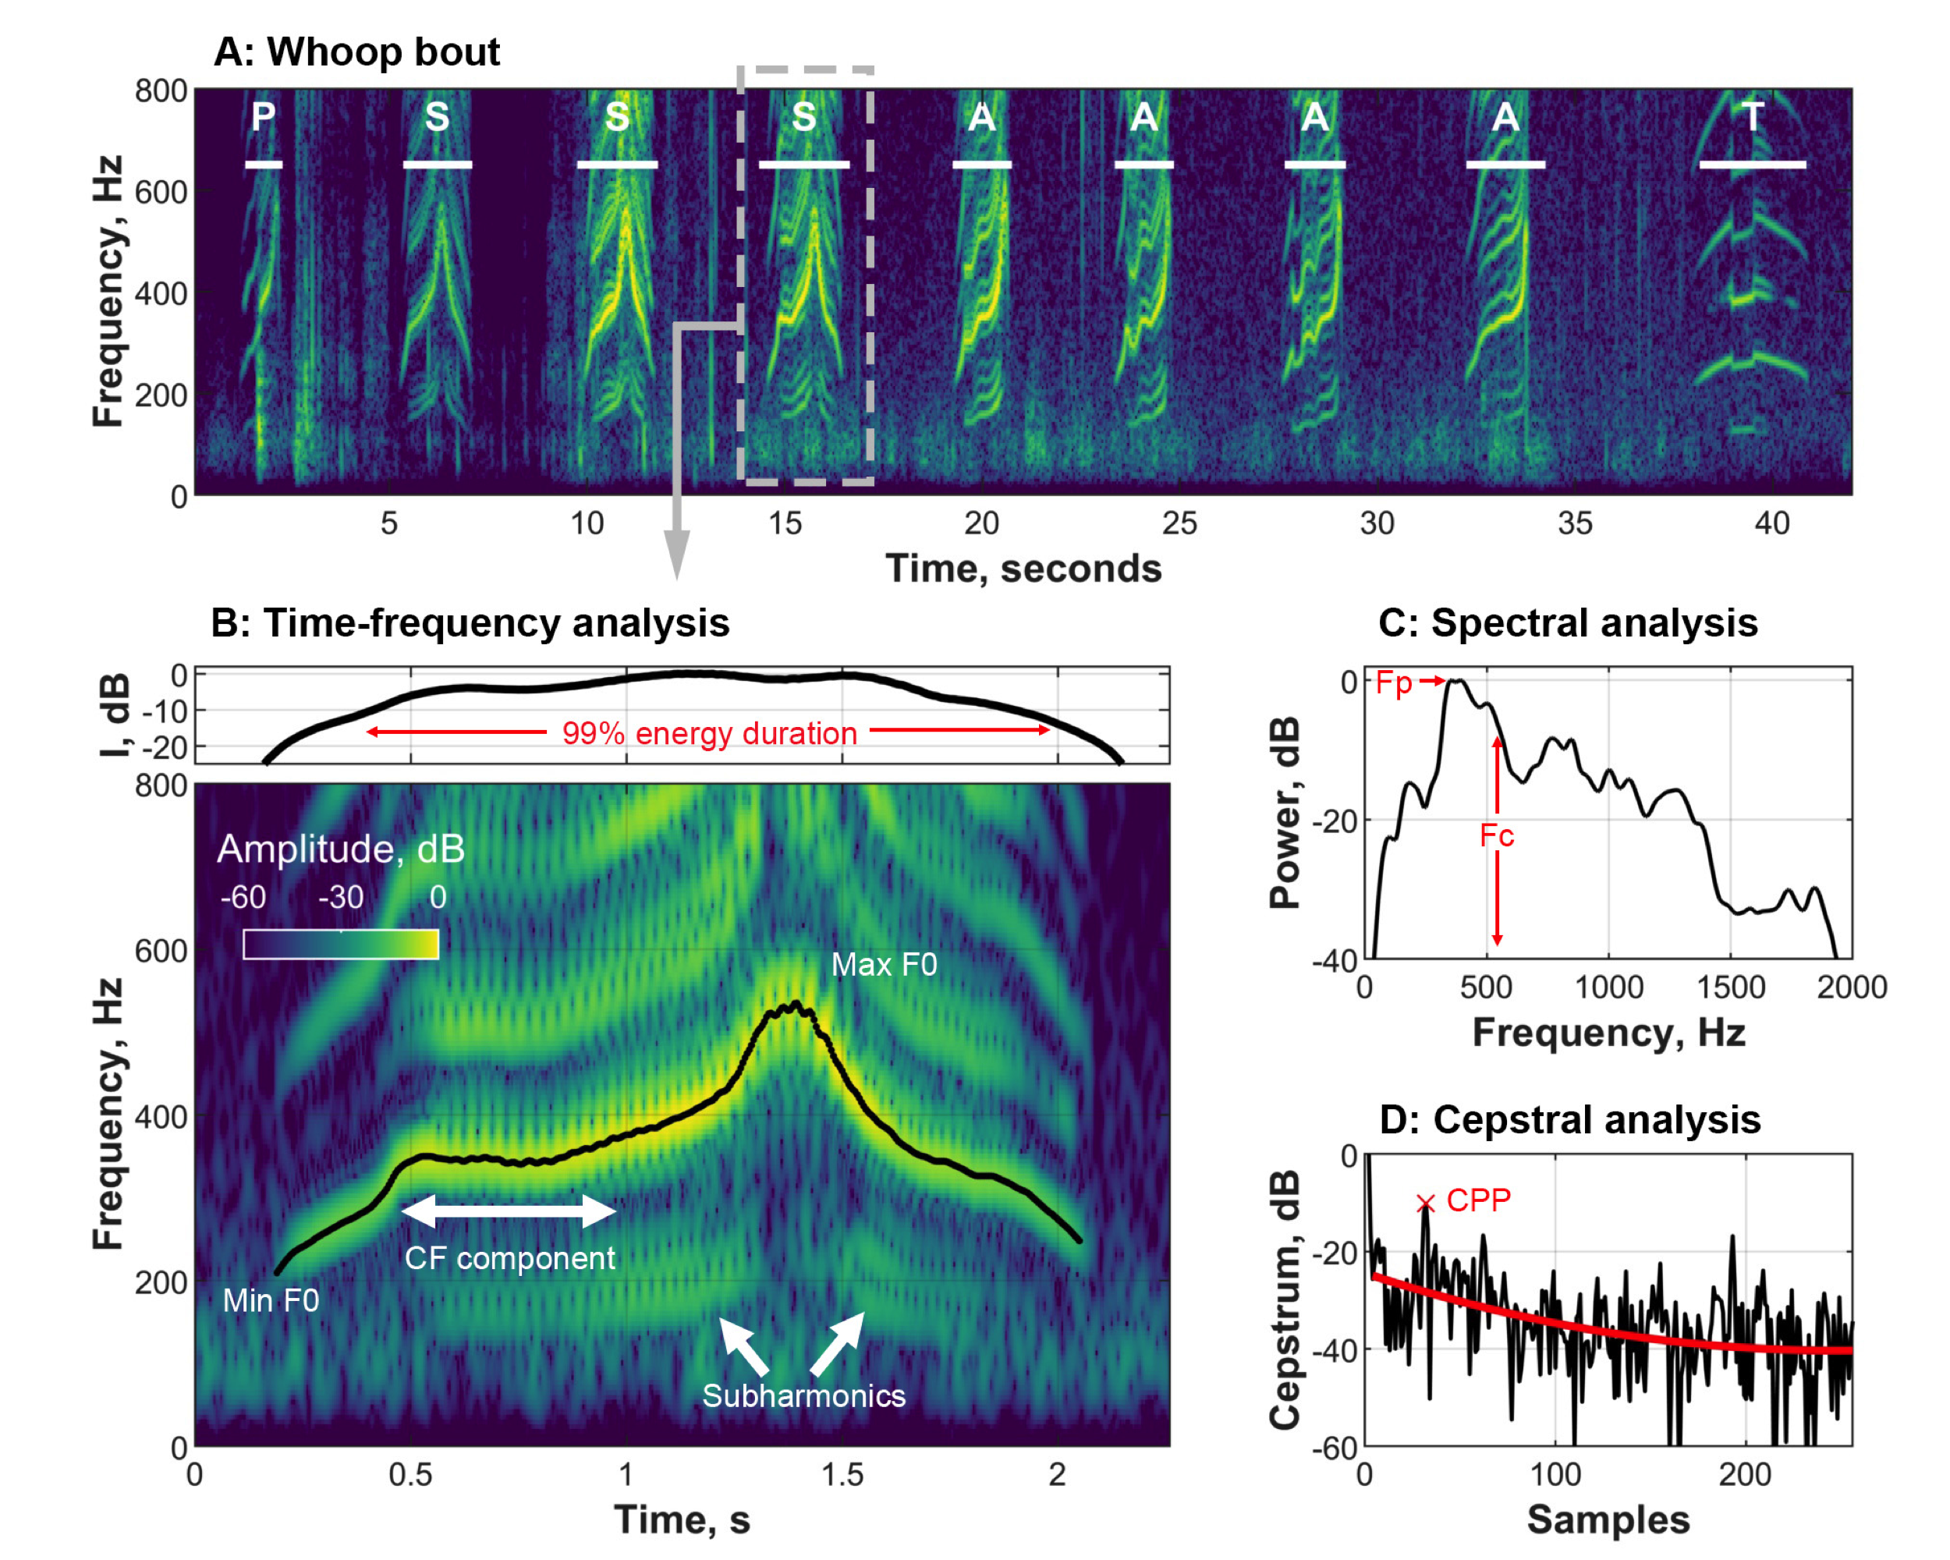

Figure 1: (A) shows a spectrogram of an exemplar whoop bout (resolution 17.1ms x 3 Hz, 90 dB dynamic range) with all four whoop types labelled either ‘S’ (symmetric), ‘A’ (asymmetric), or ‘T’ (terminal) based on East (1991), and the addition of a ‘P’ (preliminary) whoop category. (B) depicts an exemplar S type whoop, with call features labeled, including the ‘CF’ or ‘constant frequency’ portion of the whoop. (C) and (D) illustrate call features acquired from spectral and cepstral analyses respectively. See Methods for information on call parameters.

## Acoustic processing and feature extraction

Recordings were resampled to a common sample rate of 32 kHz. Each signal was then processed individually using custom-written software in Matlab 2019a [46] to extract a range of acoustic parameters (Table 1, See Supplement for full detail).

**Table 1:** Acoustic features extracted from each whoop.

| **Abbreviation** | **Measurement** | **Units** |
| --- | --- | --- |
| dur | Duration of call (99% energy criterion) | [seconds] |
| dur.cf | Duration of constant-frequency (CF) component | [seconds] |
| dur.upsweep | Duration of upsweep (until max frequency) | [seconds] |
| dur.subharm | Duration of call with dominant subharmonics (Energy > harmonics) | [seconds] |
| endtime.cf | End time of CF component relative to call | [fraction of call] |
| endtime.upsweep | End time of upsweep (max frequency) relative to call | [fraction of call] |
| freq.centroid | Centroid frequency | [kHz] |
| freq.peak | Peak frequency | [kHz] |
| freq.min | Min fundamental frequency | [kHz] |
| freq.max | Max fundamental frequency | [kHz] |
| freq.mean.cf | Mean fundamental frequency within CF component | [kHz] |
| harmonic.ratio.total | Harmonic to subharmonic energy ratio within entire call | [dB] |
| harmonic.ratio.cf | Harmonic to subharmonic energy ratio within CF component | [dB] |
| mean.entropy | Mean spectral entropy within 99% energy duration | [0(pure tone) to 1(white noise)] |
| cpp.mean | Mean cepstral peak prominence |  |
| cpp.sd | Standard deviation of cepstral peak prominence across time slices |  |

## Using random forests to predict clan membership and individual identity

To test whether whoops contain clan and/or individual signatures, we trained random forest classifiers [47] to predict either clan or individual identity based on the set of extracted acoustic features. Random forest classification is a supervised machine learning algorithm that uses a set of decision trees (i.e. a ‘forest’) to classify objects that are represented by measured features of the objects. Each tree in a forest attempts to parsimoniously split the training objects into the correct categories based on a random subset of object features, and a majority rule is used to produce a final ensemble classification across trees.

### Testing the clan signature hypothesis

We first tested whether spotted hyenas use generalizable acoustic features that help differentiate clan identity from whoops irrespective of individual identity. To investigate this, we split our full dataset (n=514 whoops from 39 hyenas in 4 clans; Table S1) into a test dataset consisting of all whoops from a randomly selected hyena from each clan, and a training dataset consisting of whoops from all other hyenas (Figure S 8a). We then trained a random forest classifier with 500 decision trees with the number of nodes set to the size of the training set, and measured the classification accuracy as the number of correctly identified whoops in the test dataset. This resulted in the whoops of any single hyena being in either the test or training dataset, but not both, thus preventing the classifier from learning the characteristics of individual hyenas and ensuring that accuracy only reflects features that generalize across hyenas within a clan. To assess the accuracy of predictions, we repeated this process 1000 times, with a random hyena from each clan selected for the test data each time.

Since animals varied in their number of recorded whoops, each random selection of test individuals resulted in a different proportion of correctly assigned whoops due to chance. As a null model, we therefore calculated a weighted expectation (WE), which is the expected proportion correct due to chance alone.

Because most male hyenas disperse from their natal clans [32,48], males may retain their natal group signature instead of learning the vocal signature of the clan in which we recorded them. We tested for this possibility by rerunning separate analyses with males only or with females only.

### Testing the individual signature hypothesis

To test whether whoops are individually distinct, we reduced the dataset to all hyenas having two or more whoop bouts (and excluded one additional female because her whoop bouts were unusually short, Supplementary Table 1). To prevent the random forest from assigning individual identity based on autocorrelated variation present within a whoop bout instead of common variation among an individual’s whoop bouts, we held out one bout from each individual for the test dataset and used the remaining whoops as training data (Figure S 8b). As before, we then trained a random forest classifier with 500 trees to predict individual identity on the training dataset, and measured performance as the fraction of whoops in the test dataset with correctly assigned individual identity. We repeated this procedure 1000 times, each time withholding a randomly selected whoop bout from each individual for the test dataset. As above, a weighted expectation probability was calculated as the fraction of whoops that would be correctly assigned to the individual by chance.

To test the possibility that individual classification accuracy was influenced by recording method, we ran this analysis separately on data from microphone recordings and collar recordings. We also reran the random forest analysis with males and females separated to determine if one sex has more individually distinctive whoops than the other.

Because whoop type affected the accuracy of assignment, we created a dataset of only A and S type whoops and retested both clan and individual signature hypotheses (Table S2). Finally, we calculated importance as the mean decrease in individual classification accuracy when each feature is excluded from the classification model using the “importance” function from the randomForest package (Table 1). Confusion matrices for all random forest analyses can be found in the Supplementary Materials.

## Testing whether signal redundancy improves caller identification

Finally, we investigated how the sequential nature of natural whoop bouts influences classification accuracy and thus might help alleviate uncertainty about caller identity. To do this, we simulated a receiver’s likelihood of assigning a whoop bout to the correct caller based on multiple whoops in the bout. Within a random forest model, we calculated each test bout’s accuracy by calculating the proportion of decision trees that classified each bout to each of the hyenas in the dataset given one whoop, two whoops, etc. This gave us a ‘probability’ that each bout belongs to each hyena for each number of whoops within the bout.

We then calculated the average correct probability across all the random forest models to account for variations in prediction accuracy from using different whoops for training and testing. This analysis used the random forests trained with only ‘A’ and ‘S’ whoops but otherwise maintained the natural order of whoops within the bout.

All analyses and figures were generated in RStudio with R version 4.1.1 (2021-08-10)[49] and Bookdown 0.24 [50]. We analyzed data using the tidyR 1.1.4[51] and randomForest 4.6.14[52] packages, and created figures using gplots 3.1.1[53], ggplot2 3.3.5[54], and cowplot 1.1.1[55]. Diagrams were created in Powerpoint and colors were generated from viridis 0.6.2[56].

# Results

The random forest model for assigning clan membership was no more accurate than expected by chance (Figure 2, mean: 0.32, sd: 0.15, chance: 0.24). In contrast, the random forest model for assigning individual identity was much more accurate than expected by chance (Figure 3, mean: 0.54, sd: 0.058, chance: 0.09). These results held true regardless of sex or recording method, even with the reduced sample sizes in these datasets (Figures 2c and 3c). The accuracy of individual assignment did vary with whoop type (with A, S and P assigned more accurately than T, Figure 3b) and final analyses were conducted with only ‘A’ and ‘S’ type whoops (Figures 2c and 3c). These whoop types are well represented in the dataset and are unlikely to be ‘alerting elements,’ which draw the attention of the receiver without providing information [57,58]. The accuracy of assignment to clan and individual varied considerably among the clans (Figure 2d) and individual callers (Figure 3e).

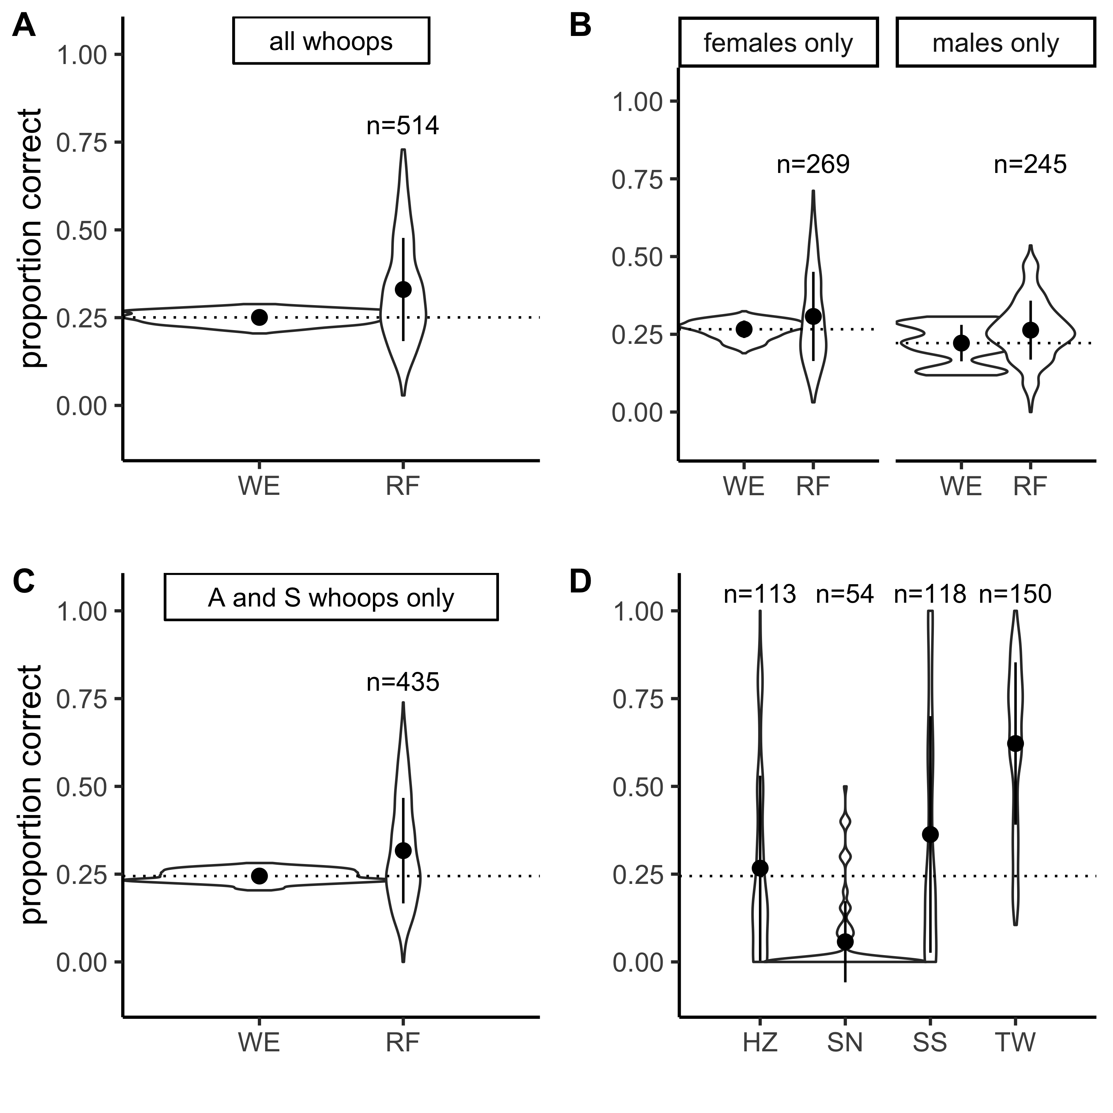

Figure 2: Lack of clan identity information in single whoops. Violin plots of proportion of test data correctly assigned to clan from 1000 random forests. (A) Comparing random weighted expectation (WE) to performance of the random forest overall (RF), using all whoop types. (B) Comparing WE and RF for datasets composed of whoops from females only and males only. (C) Comparing WE and RF using only ‘A’ and ‘S’ type whoops. (D) Random forest accuracy of test data for each hyena clan, using only ‘A’ and ‘S’ type whoops. Points and bars represent means and standard deviations of random forest accuracy. Dotted line indicates mean random weighted expectation for that dataset.

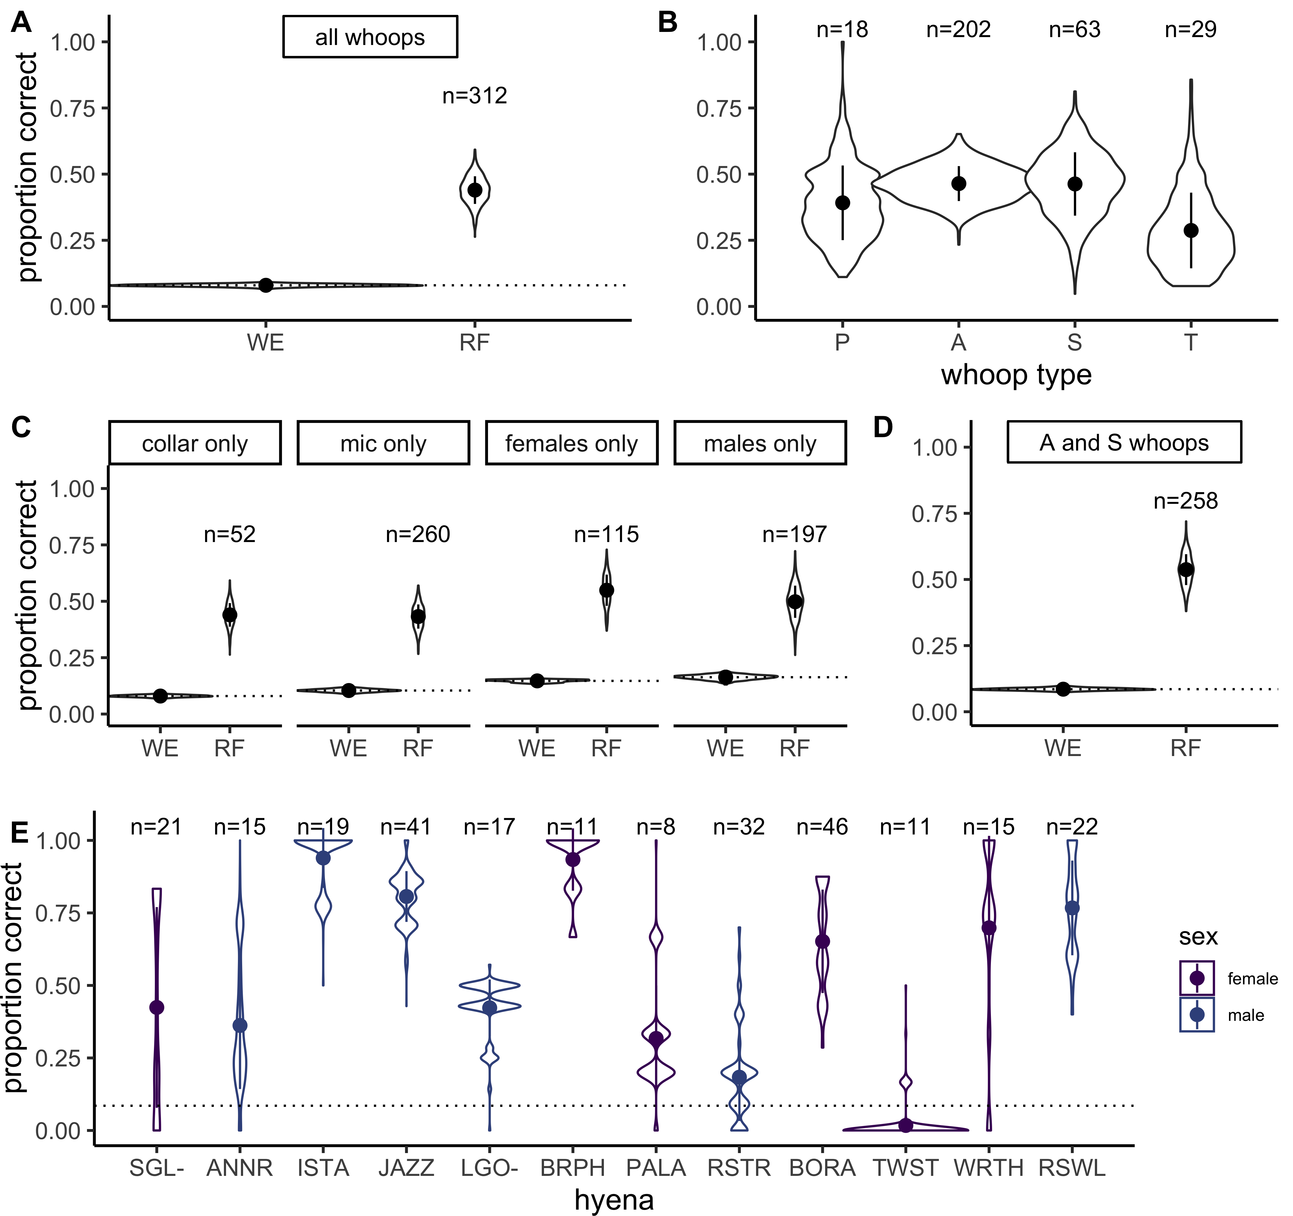

Figure 3: Individual identity information in single whoops. Violin plots of the proportion of test data correctly assigned to individual from 1000 random forests. (A) Comparing random weighted expectation (WE) to performace of the random forest overall (RF), using all whoop types. (B) Random forest accuracy by whoop type. (C) Comparing WE and RF for datasets composed of collar recordings only, microphone recordings only, females only, and males only. (D) Comparing WE and RF using only ‘A’ and ‘S’ type whoops. (E) Random forest accuracy for individual hyenas, using only ‘A’ and ‘S’ type whoops. Points and bars represent means and standard deviations of random forest accuracy. Dotted line indicates mean random weighted expectation for that dataset.

Some call features were more important than others for correctly predicting individual caller identity (Figure 4). The top features were: the mean frequency of the constant frequency portion of the whoop, the maximum frequency, and the duration.

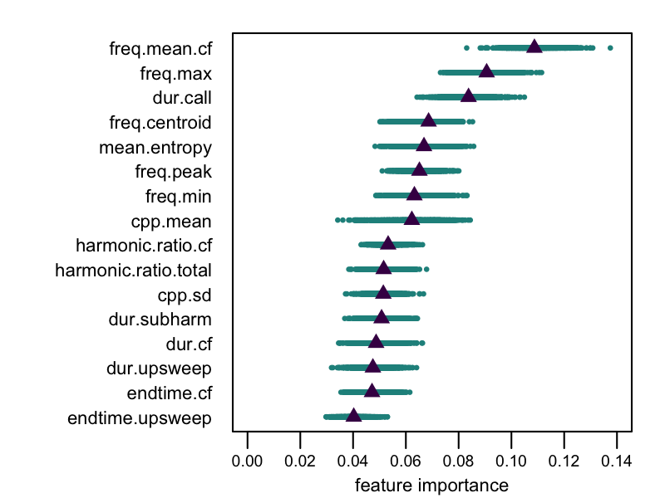

Figure 4: The importance of each whoop feature in predicting individual identity. Feature importance is measured as the mean decrease in accuracy when that feature is removed from the random forest analysis. See Table 1 for full feature names and descriptions.

Our analysis of whoop redundancy within a bout supported the hypothesis that the repetitive nature of the whoop bout increases receiver certainty about the identity of the caller. With more whoops in a bout, the proportion of correct guesses increases, although not at the rate expected if all whoops are equally informative (Figure 5).

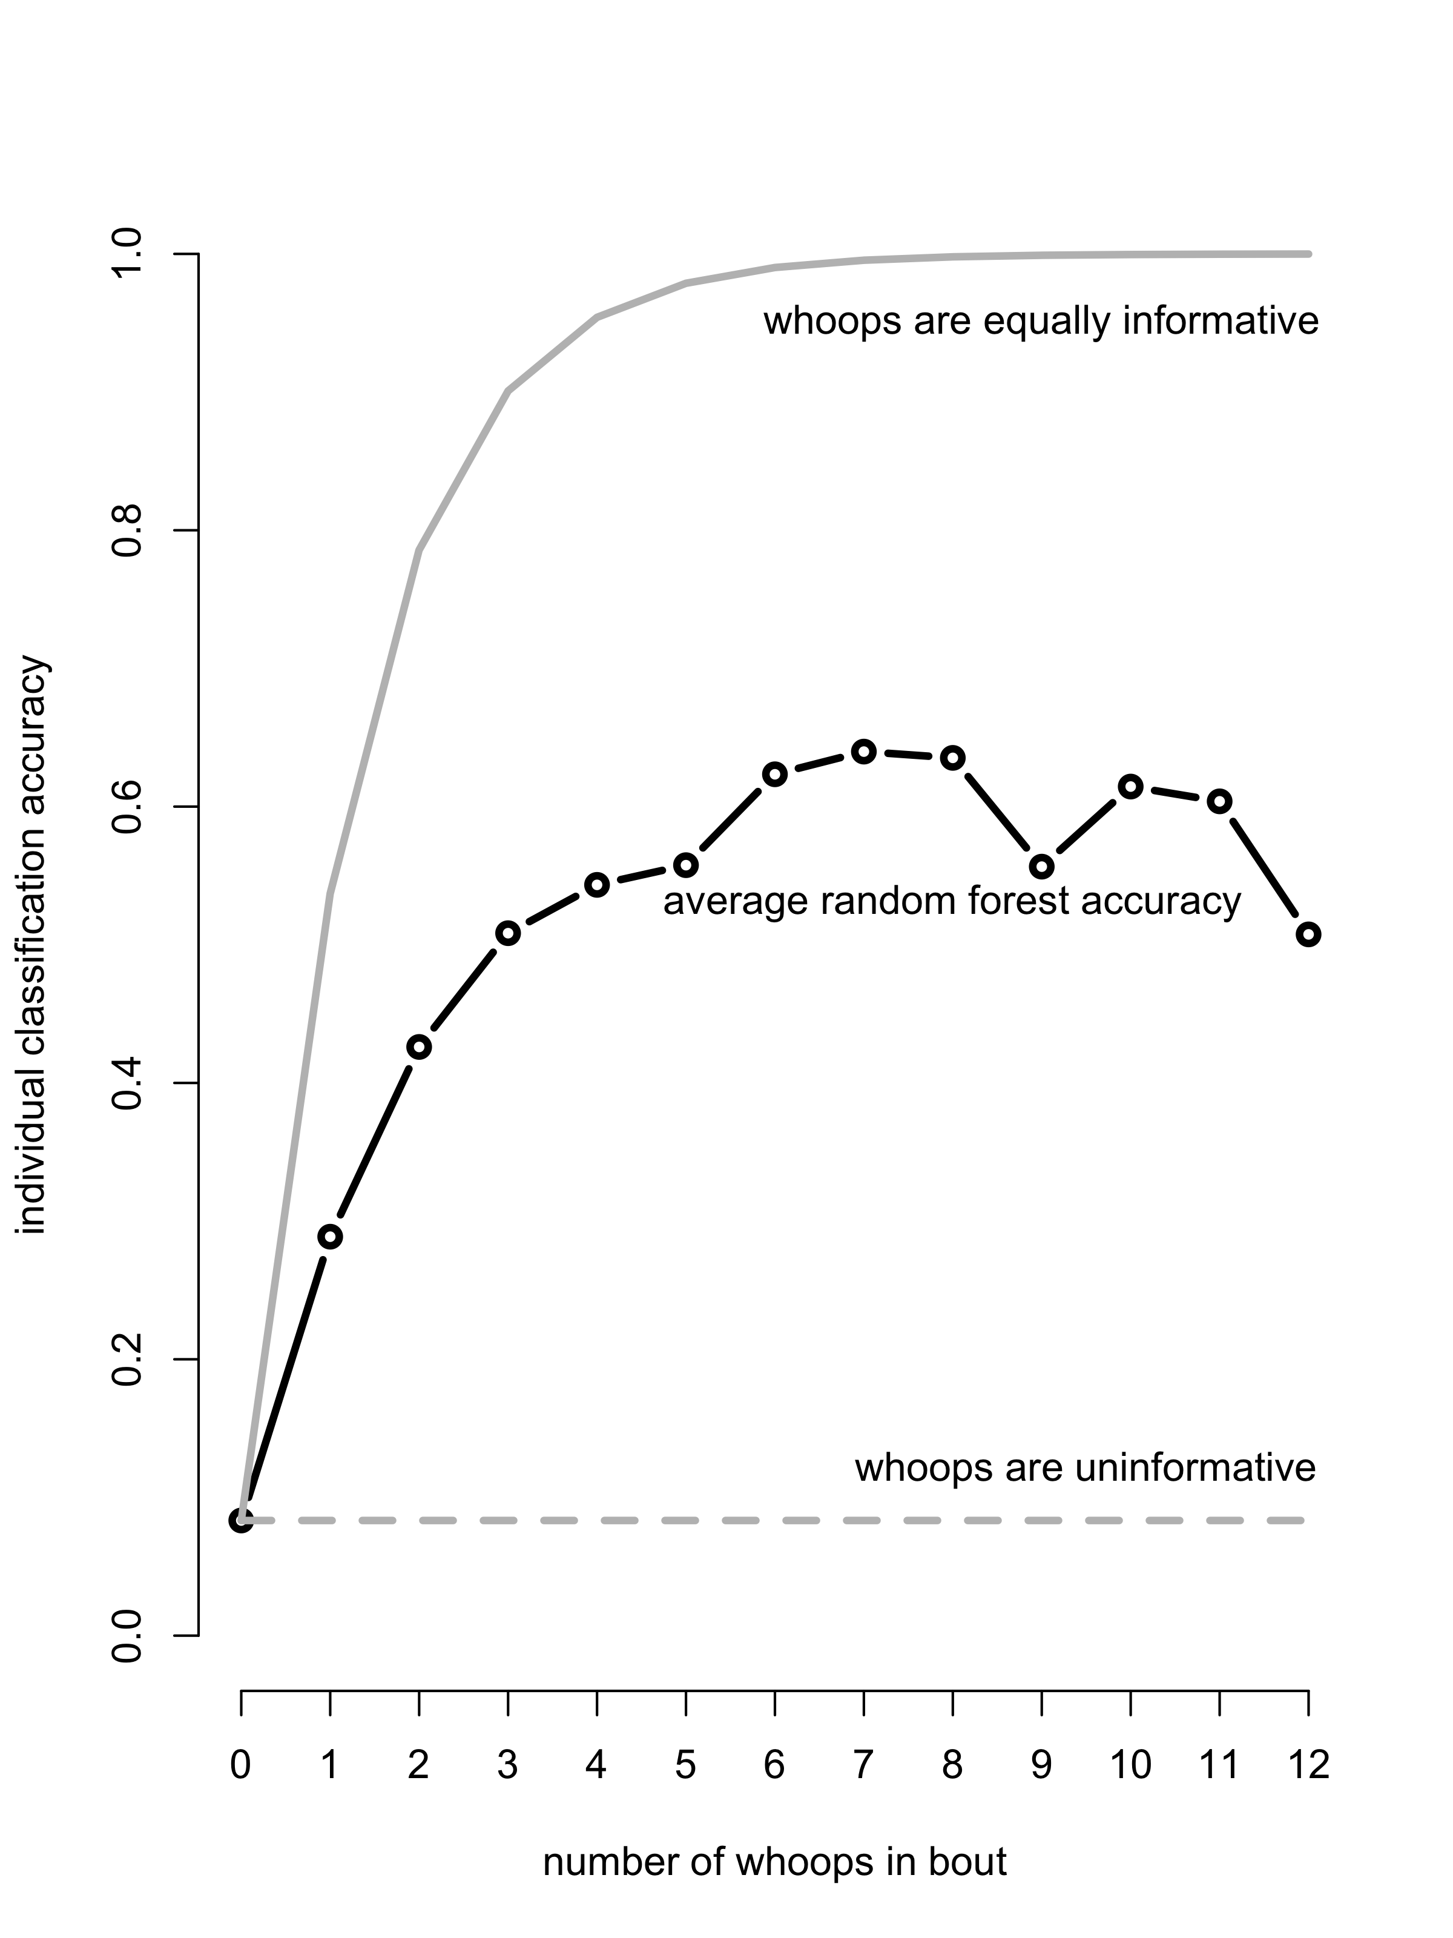

Figure 5: The sequential nature of whoop bouts increases assignment accuracy. The expected proportion of correct guesses of caller identity improves with number of whoops examined in the bout based on the random forest predictions (solid black). The average accuracy as a function of the number of whoops in a bout given the null hypothesis that whoops are uninformative (dotted line) and given that each whoop is equally informative (using the average accuracy of the 1000 random forests trained with ‘A’ and ‘S’ type whoops: solid line).

# Discussion

## Individual instead of group signatures

Species will evolve signals that meet their minimum needs [5] while using as few categories of signals as possible to maximize detection and discrimination [1]. Given the size [26,27], dynamic membership, and spatial dispersion of hyena groups, they are a strong candidate species for a group signature. This group signature would allow hyenas to categorize callers to ‘clan-mate or not,’ thereby facilitating the coordination and recruitment of clan-mates and detection of territorial intruders. We found multiple call features that facilitate individual discrimination, but no evidence of a group-level signature. This suggests several possibilities about the relationship between hyenas’ fitness-critical needs and the resultant structure of their communication: (1) recognition of large numbers of group-mates by voice alone may not be as costly as expected; (2) group signatures may be more costly than expected; (3) group signatures may not meet hyenas’ minimum needs, nor any need beyond those already met by individual signatures.

There is some evidence that vocal recognition of many individuals is not costly enough to require the categorical reduction that group signatures would provide. While it is difficult to determine the number of voices recognized by humans experimentally, we do know that humans can accurately distinguish a large number of individuals from voice alone [59–62]. In addition, several studies in non-human animals have demonstrated individual vocal recognition [63–68] (although see [69]). Some species are clearly capable of recognizing numerous individual callers (approximately 100 individuals in African elephants [70]) and even associate callers with traits lying on multiple axes (such as rank and kinship [71,72]). Hyenas already have the cognitive capacity to recognize and remember clan-mates as individuals [29,31,73]; perhaps the development of a group signature is more costly than the memory capabilities necessary to recognize 125+ voices.

Evolving a group signature would also require concurrent evolution of flexible vocal production learning [74], a relatively rare trait in animals [75]. Without this trait, an individual would be unable to learn and produce a new group signature after changing groups. During clan fission [76] and male immigration [32,48], hyenas would need to learn how to produce the group signature of their new clan. While hyenas may still be capable of flexible vocal production, our results suggest that a group signature is not the impetus. Instead, the individual signatures we detected would rely on hyenas’ associative learning and flexible vocal comprehension [75]. Male hyenas especially may have to learn to recognize the individually distinct calls of an entirely new suite of group-mates while other animals in a male’s new clan must learn to recognize the new immigrant’s voice.

The lack of group signatures in whoops also suggests that a simple ‘group-mate or not’ classification is insufficient for spotted hyenas to respond adaptively to these vocalizations. This is consistent with the hypothesis [7] that individual signatures in vocal calls are tied to the evolution of differentiated social relationships in complex societies. Hyena society does possess characteristics that support the evolution of identity signaling, specifically, complex and repeated social interactions, dominance hierarchies, and territoriality [2]. Spotted hyenas show social preferences for certain group-mates based on kinship and dominance [77,78], and social alliances can restructure the social hierarchy [79] to influence rank and fitness [80]. Therefore, long distance calls encoding individual identity may be crucial to the functioning of hyena societies, allowing group members to manage numerous social relationships occurring over large spatial scales. The memorization of these individual signatures then provides the requisite group membership information for mediating an effective cooperative territory defense, thus obviating the need for a group signature.

Interestingly, some whoop types and some individuals were more difficult to correctly categorize; however, we cannot disentangle whether this is a product of our dataset or if it represents meaningful differences among whoop types and individual voices. ‘A’ type whoops may be more easily classified because they are over-represented in the dataset or ‘A’ whoops may be more common within whoop bouts because their protracted constant frequency portion is a good indicator of individual identity (Figure 4). *Frants suggested citing Wijers 2021 here, but that paper seems to suggest that it’s variation in the fundamental frequency that makes it easier to ID caller, whereas we’re talking about the constant frequency portion making A whoops easier to classify* T whoops may have been poorly classified due to their under-representation, or they may not encode individual identity at all. The variation in individual assignment accuracy may be an artifact of the recordings we happened to obtain (e.g. our two recorded bouts happen to span the variation produced by that individual), or it might reflect real challenges that hyenas face in the wild. Some individuals (e.g. low ranking individuals) may benefit from being more difficult to identify, or the acoustic space may not be large enough to accommodate a large number of distinct signatures.

## Call features adapted for long-range transmission

To solve the challenge of communicating individual identity across extensive territories, spotted hyenas seem to have evolved to encode identity information in features that are particularly robust to long-range propagation. The call features that were most important for discriminating individuals included a number of frequency measures (mean frequency of the constant-frequency portion of the whoop, maximum and minimum frequency of the fundamental, and centroid frequency), call duration, and measures of noisiness (entropy) and dysphonia (CPP mean). Frequency features are common identifiers in other species with individual vocal recognition [81] and other species that rely on long-range signaling seem to have evolved similar adaptations, including wolves [82], lions [83], and bottlenose dolphins [8]. Long-distance vocal signals often contain frequency modulation, amplitude modulation, or both [84–88], as seen here in hyena whoop bouts. Each individual whoop in a bout contains contains modulation over a wide range of frequencies, while the bout itself contains patterned amplitude modulation via the alternation of loud whoops and silent intervals. The importance of the entropy and cepstral peak prominence measures suggest hyenas might also attend to the biphonic components that are common for some hyena whoops. While these features are unlikely to transmit over long distances, they are a common identifier in the voices of a number of species [81].

In addition to identifying individual hyenas, frequency features may also make it easier for hyenas to locate a whooping individual [39] since calls with a wide frequency range are expected to facilitate localization of the sound source [89]. Low frequencies are also easier to locate in most situations [22], and are thus advantageous for long-distance calls that advertise the caller’s location. The high frequency portions, which degrade more quickly, may allow a receiver to ascertain the distance of the caller from it while the low frequency portions of the call ensure it reaches as many receivers as possible.

## The value of repetition

Signal redundancy has been shown to improve recognition accuracy in models [90], so redundancy within whoop bouts likely increases both the probability of detection and the receiver’s ability to identify the caller. This notion was supported by our calculations of increasing classification accuracies over the course of whoop bouts although this increase did not reach the classification accuracies expected if each whoop was equally informative and accuracy with each additional whoop followed a Bayesian updating rule. This reduced accuracy is likely due to each whoop within a bout *not* being an independent observation. Each random forest was trained on one bout less than the number of bouts available for each individual. This ensured that random forest accuracy was due to individual-level, and not bout-level, characteristics, but also resulted in some bouts with low accuracy. This correlated error is certainly an artifact of machine learning, but may also reflect challenges experience by receivers in the wild when consecutive signals have redundant information leading to correlated errors.

In systems where signalers are unable to predict how signals degrade during transmission or the amount of noise that their receivers will experience, additional repetition increases the chance that a signal is detected and correctly decoded. It is important to note that our calculation of the prior probability that a bout belongs to any individual will be much different than the prior probabilities that a hyena will encounter in the wild. Although most spotted hyenas must discriminate between many more than the twelve individuals we distinguish here, they likely also have prior information regarding which individuals are nearby or in a particular direction. The repetition of whoops within the bout also provides multiple opportunities for receivers to localize the caller [91] while also deriving information from tonic features of the bout, specifically the inter-whoop-interval [37].

This serial redundancy within whoop bouts also allows for subsequent divergence between repeated elements and co-option of a derived element for a new purpose [25]. For example, whoop bouts often start with a ‘P’ type, truncated whoop, a simple tonal call that may serve as an alerting component [57]. Thus, it is possible that each whoop type conveys a different kind of information, that the sequence conveys information, or even that two hyenas share similar ‘S’ whoops and different ‘A’ whoops. Unfortunately, our sample size was not large enough to directly test these hypotheses here.

*This paragraph was an attempt to hit home the novelty of the repetition analysis. At one point we talked about that being one of the more interesting parts of the paper and worth driving home. But let me know if you all thing it should just be cut* Although there have been a number of studies on increased redundancy in calls due to increased noise in the environment, to our knowledge no studies have previously attempted to quantify the increase in accuracy of information transfer as the redundancy of the signal increases. There is an important push in the animal behavior literature to investigate degenerate signals in multimodal signaling systems [24,92], especially when studying the interaction between social and communicative complexity [93]. We suggest this should also extend to redundancy over time because animals are constantly integrating signals and new information into their decisions.

## The function of advertisement whoops

It is noteworthy that while whoops are used to recruit clan-members for collection action, a large proportion (47.1% [38] to 60% [31]) of whoop bouts are “spontaneous” or “slow” and do not appear to recruit individuals [37], suggesting they serve an additional function. We concur with East and Hofer’s [39] suggestion that spontaneous whoops display the identity and location of the caller, and as such they can help hyenas keep track of conspecifics and thus simplify the task of discriminating between conspecifics by informing the prior probability of where conspecifics should be located. However, we we also suggest that these bouts may reinforce the templates, or mental representations of calls, of receivers within hearing distance [1,94]. This function of spontaneous whoops may be especially important given that receivers must discriminate among many group-mates and between group and non-group mates with the potential for correlated error and without the benefit of a group signature. Such memory reinforcement should improve future detection and discrimination as it does in humans [1].

# Acknowledgements

We thank the Kenyan National Commission for Science, Technology and Innovation, the Narok County Government, the Mara Conservancy, and the Kenya Wildlife Service for permission to conduct our long-term study. We also thank all those who assisted with data collection in the field, and with data entry and manipulation in the lab. This work was supported by National Science Foundation Grants OISE1853934 and IOS1755089, Carlsberg Foundation Grant CF 15-0915, and by Human Frontiers in Science Program Grant RGP0051/2019. KDSL was supported by a Graduate Research Fellowship from NSF. ASP received additional funding from the Gips-Schüle Stiftung and the Zukunftskolleg at the University of Konstanz. FHJ was funded through an AIAS-COFUND fellowship from Aarhus Institute of Advanced Studies under the FP7-PEOPLE programme of the EU (agreement no. 609033).

# Supplemental

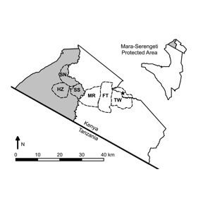

Figure 6: Figure S1: Map of the Mara Hyena Project study clans in the Maasai Mara, Kenya. The appoximate clan boundaries are indicated by dashed lines. The Talek West (TW) territory lies on the eastern side of the Reserve, approximately 25 km from the remaining three clans which occupy adjacent territories on the western side of the Reserve: Happy Zebra (HZ), Serena South (SS), and Serena North (SN). Reproduced from Green 2015.

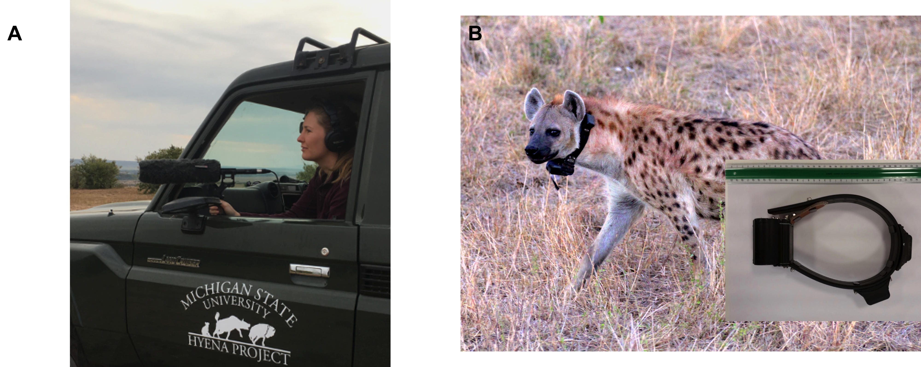

Figure 7: Figure S2: Acoustic recordings were obtained from wild spotted hyenas in the field using either (A) handheld shotgun microphone and recording setup deployed from offroad vehicles, or (B) custom-made acoustic and movement recording collars sampling sound directly from the tagged animal. Observers deployed recording equipment once the vehicle was turned off and aimed the handheld directional microphone (ME-66/K6 and ME-67/K6, sensitivity: 50 mV/Pa, frequency response: 40 Hz–20 kHz; Sennheiser Electronic Corporation, Old Lyme) toward vocalizing animals within 50 meters of the car. For these recordings, observers used a Marantz PMD661 handheld solid-state recorder (Marantz America, Inc., Mahwah, NJ; Figure 8a) at sampling rates of 44.1, 48, or 96 kHz and 16 or 24-bit sampling depths. From April 2010 to January 2011 recordings were elicited via call-in playbacks (fully described in Gersick et al. 2015) and from July 2014 to April 2016 recordings were obtained opportunistically. Each collar consisted of a base Followit Wildlife (Followit AB, Lindesberg, Sweden) Medium Iridium collar with reinforced belting, integrated VHF antenna and a GPS and iridium module for transmitting location and battery state. Each collar was fitted with a secondary sound and movement module consisting of a modified digital acoustic tag (DTAG: Johnson and Tyack, 2003, Johnson et al. 2009) connected using a serial cable to a high sample rate Gipsy-5 GPS module (Technosmart Europe, Rome, Italy). This module was placed on the top of the collar and thus located on the back of the neck with the microphone facing forward and protected by an oleophobic acoustic vent (GAW325, 3.2mm ID, W. L. Gore and Associates, Elkton, MD, USA). Collars digitized sound using a sigma-delta ADC with an oversampling rate of x6, for a final 32 kHz sampling rate and 16-bit depth.

**Table 2:** Table S1. Summary of datasets used in random forest analyses. The clan signature hypothesis was tested with datasets composed of all whoop types (PAST Clan) and only A and S whoop types (AS Clan). The PAST Clan dataset was further divided into females only and males only datasets (see status and sex column). The individual signature hypothesis was tested with datasets composed of all whoop types (PAST Individual) and only A and S whoop types (AS Individual). The PAST Individual dataset was divided into recordings from females only, males only (see status and sex column), microphone only, and collar only. Bolded individuals’ recordings were obtained from recording collars.

| **hyena** | **clan** | **status & sex** | **whoops per bout in dataset** | | | |
| --- | --- | --- | --- | --- | --- | --- |
| **PAST Clan** | **AS Clan** | **PAST Individual** | **AS Individual** |
| JLYR | HZ | natal female | 8 | 6 |  |  |
| *PIKE* | *HZ* | *natal female* | *6* | *6* |  |  |
| SGL- | HZ | natal female | 5,6 | 5,6 | 5,6 | 5,6 |
| *SNAP* | *HZ* | *natal female* | *8* | *6* |  |  |
| ANNR | HZ | imm. male | 7,10,11 | 6,7,8 | 7,10,11 | 6,7,8 |
| ISTA | HZ | imm. male | 7,6,4,10,13,9 | 6,5,4,9,10,7 | 7,6,4,10,13,9 | 6,5,4,9,10,7 |
| JAZZ | HZ | imm. male | 11,7 | 10,7 | 11,7 | 10,7 |
| PGLG | HZ | imm. male | 5 |  |  |  |
| TEMP | HZ | imm. male | 7 | 5 |  |  |
| *ANGI* | *SN* | *natal female* | *8* | *8* |  |  |
| LOGC | SN | natal female | 9 | 9 |  |  |
| *RBC-* | *SN* | *natal female* | *12* | *11* |  |  |
| RMON | SN | natal female | 6 | 6 |  |  |
| *LGO-* | *SN* | *imm. male* | *8,5* | *7,4* | *8,5* | *7,4* |
| RALI | SN | imm. male | 10 | 9 |  |  |
| *BADG* | *SS* | *natal female* | *7* | *6* |  |  |
| *BBW-* | *SS* | *natal female* | *6* | *6* |  |  |
| *BRPH* | *SS* | *natal female* | *7,8,9* | *6,6,7* | *7,8,9* | *6,6,7* |
| *GRIM* | *SS* | *natal female* | *6* | *6* |  |  |
| *JAVA* | *SS* | *natal female* | *10* | *9* |  |  |
| KOMO | SS | natal female | 7 | 7 |  |  |
| *KS--* | *SS* | *natal female* | *5* | *5* |  |  |
| *MTN-* | *SS* | *natal female* | *8* | *8* |  |  |
| PALA | SS | natal female | 6,3 | 5,3 | 6,3 | 5,3 |
| *TAJ-* | *SS* | *natal female* | *6* | *6* |  |  |
| DEE- | SS | imm. male | 6 | 6 |  |  |
| ONEK | SS | imm. male | 5 |  |  |  |
| *RSTR* | *SS* | *imm. male* | *11,13,11* | *10,12,10* | *11,13,11* | *10,12,10* |
| **BORA** | **TW** | **natal female** | **8,10** | **7,8** | **8,10** | **7,8** |
| **BYTE** | **TW** | **natal female** | **7,2,2** | **5** |  |  |
| **FAY-** | **TW** | **natal female** | **2,7,4,1** | **1,7,1** | **7,4** |  |
| HRPY | TW | natal female | 5 | 5 |  |  |
| **MGTA** | **TW** | **natal female** | **4,2** | **3,2** |  |  |
| ROOS | TW | natal female | 12 | 11 |  |  |
| TWST | TW | natal female | 7,12 | 6,9 | 7,12 | 6,9 |
| **WRTH** | **TW** | **natal female** | **1,12,1,7,4,1,2** | **1,12,6,4,1,2** | **12,7,4** | **12,6,4** |
| DDMA | TW | imm. male | 8 | 7 |  |  |
| RSWL | TW | imm. male | 6,8,2,8,12,9,7,4 | 5,7,1,6,11,8,5,4 | 6,8,8,12,9,7,4 | 5,7,6,11,8,5,4 |
| ZITI | TW | natal male | 5 | 5 |  |  |
| Bolded lines are data obtained from recording collars. | | | | | | |
| Italicized lines are data obtained from call-ins. | | | | | | |

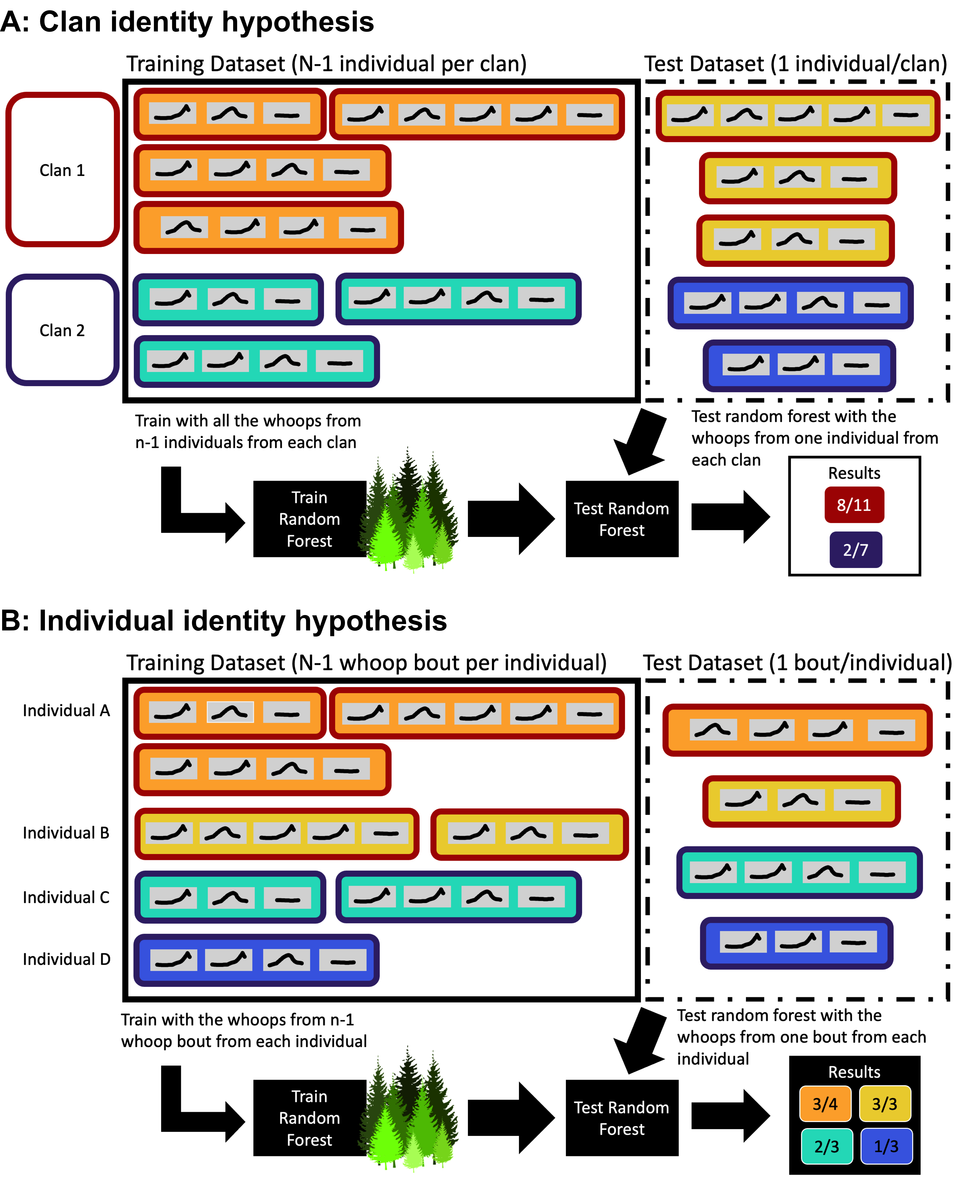

Figure 8: Figure S3: Random forest testing and training dataset for (A) clan signature analysis and (B) individual signatures analysis. Colored rectangles represent whoop bouts (with variable number of whoops), with box fill indicating the individual and box border indicating clan. For the clan signature analysis (A), the random forest was trained using whoops from all but one individual per clan, with the remaining individuals (one per clan) used for testing. The random forest was trained on single whoops and was blind to the individual and bout. The random forest was then used to predict the clan membership of each whoop and the proportion of correct guesses was recorded. This procedure avoids pseudo-replication of individuals, and ensures that the accuracy is not artificially inflated by the model learning signatures of the individuals comprising the clan rather than signatures of the clan itself. For the individual signatures analysis (B), the random forest was trained on whoops from all but one bout per individual, with the remaining bout held out for testing. The trained random forest model was then used to predict the caller of each whoop in the test dataset. This procedure prevents psuedo-replication of bouts and eliminates the possibility of within-bout similarities affecting the analysis of individual signatures.

## Signal processing methods

*Note: I’ve never put so much info into the Supplement. Is this the best way to do this? I kept everything in the order it’s referenced in the main doc.*

First, each signal was bandpass filtered using a 6-pole Butterworth filter (-3 dB cutoff points 100 Hz to 10,000 Hz) and the 99% energy duration of the signal was calculated after subtracting average noise energy. Within this time window, a power spectrum was calculated using Welch’s method (FFT size of 8192, block size 40 ms, block overlap 35 ms, Hann window), and used to estimate the peak frequency (containing most signal energy) and the centroid frequency (separating the power spectrum into two halves with equal energy).

Next, a spectrogram was generated (FFT size of 8192, block size 40 ms, block overlap 35 ms, Hann window) and used to extract the fundamental frequency contour using a semi-supervised contour tracker. From the contour, 7 features were extracted: The minimum and maximum contour frequency were taken directly from the contour. The contour was segmented into an initial flat “constant-frequency” (CF) component (ending when contour frequency exceeded median frequency by more than 10% of the difference between median and maximum frequency) and an upsweep component (ending at the point of maximum frequency) and both the total duration and the relative time into call where each period ended were extracted, as well as the centroid frequency within the initial CF portion (see Figure 1b-d).

Some whoops contained portions with pronounced subharmonics. To find and quantify these events, the acoustic energy in the fundamental frequency, first harmonic and second harmonic (1 f0, 2 f0, 3 f0) was isolated and compared to energy in uneven harmonics (1.5 f0, 3.5 f0, 3.5 f0) using a variable-frequency filter [95]. For the fundamental frequency, -3 dB cutoff points for each time slice corresponded to the instantaneous fundamental frequency ± ¼ octave to get a filter width of 0.5 octave. For higher harmonics, the fundamental frequency was multiplied by harmonic number before calculating cutoff points. The total energy was summed across even harmonics and across uneven harmonics separately. Then, the ratio of energy within harmonics relative to energy within subharmonics was calculated and converted to deciBels (10 log10(Eharmonics/Esubharmonics) for both the entire call and for the initial constant-frequency component.

Finally, the signal was downsampled to 8 kHz. For each time slice (40 ms block size, 35 ms block overlap) within the 99% energy duration of the signal, we calculated the spectral entropy [96] and cepstral peak prominence [97,98] and finally we calculated the mean spectral entropy and cepstral peak prominence across the entire signal.

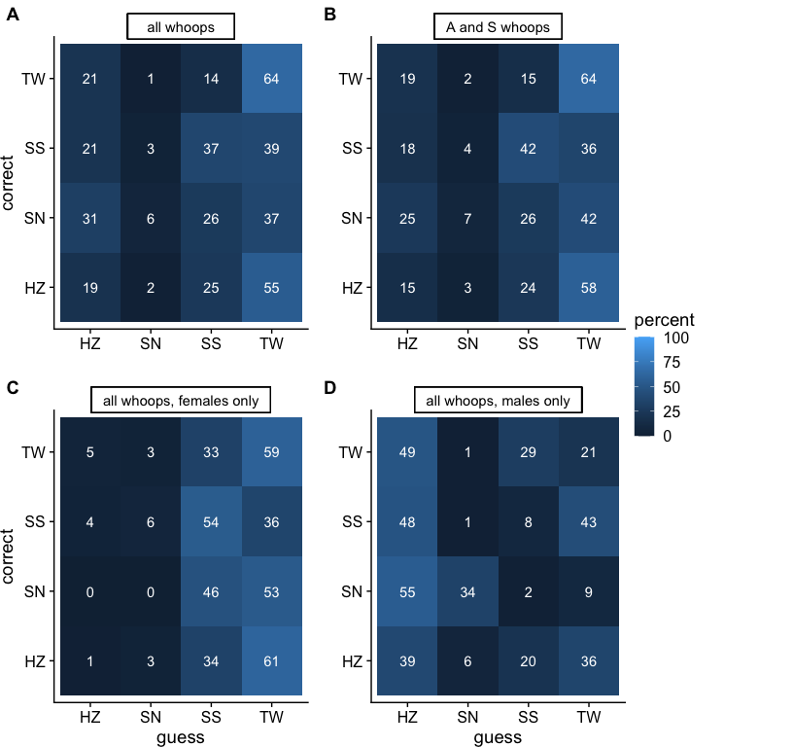

Figure 9: Figure S4: Confusion matrices for clan signature. (A) Using all whoop types. (B) Using only A and S type whoops. (C) Using all whoop types from females only. (D) Using all whoop types from males only. Rows represent true categories while columns represent the random forest assignments. Each row shows how the random forest classified calls for that particular clan. Each cell represents the percentage of calls that were assigned to the column category from the true category. Guesses that lie along the diagnal are correct assignments while guesses on either side of the diagnal are incorrect assignments. Numbers in white text show the percentage of calls assigned to category x (row x) when it came from category y (row y).

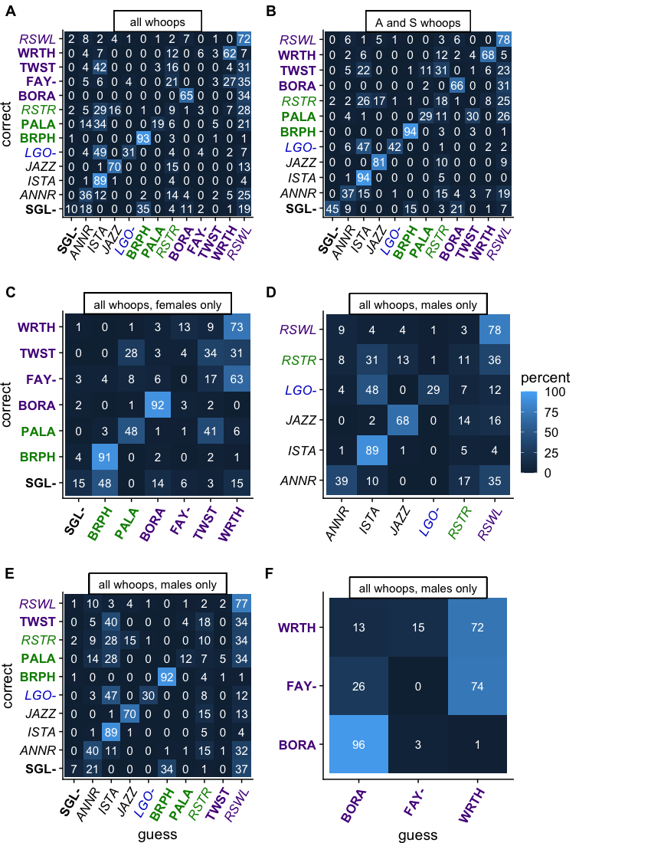

Figure 10: Figure S5: Confusion matrix for individual signature (A) Using all whoop types, (B) Using only A and S type whoops, (C) Using all whoop types from females only, (D) Using all whoop types from males only, (E) Using all whoop types from microphone recordings, (F) Using all whoop types from collar recordings. Rows represent true categories while columns represent the random forest assignments. Each row shows how the random forest classified calls for that particular clan. Each cell represents the percentage of calls that were assigned to the column category from the true category. Guesses that lie along the diagnal are correct assignments while guesses on either side of the diagnal are incorrect assignments. Numbers in white text show the percentage of calls assigned to category x (row x) when it came from category y (row y).

# References

1. Wiley RH. 2006 Signal Detection and Animal Communication. *Advances in the Study of Behavior* **36**, 217–247. (doi:[10.1016/S0065-3454(06)36005-6](https://doi.org/10.1016/S0065-3454(06)36005-6))

2. Tibbetts Ea, Dale J. 2007 Individual recognition: it is good to be different. *Trends in ecology & evolution* **22**, 529–37. (doi:[10.1016/j.tree.2007.09.001](https://doi.org/10.1016/j.tree.2007.09.001))

3. Seyfarth RM, Cheney DL. 2015 Social cognition. *Animal Behaviour* **103**, 191–202. (doi:[10.1016/j.anbehav.2015.01.030](https://doi.org/10.1016/j.anbehav.2015.01.030))

4. Reeve HK. 1989 The Evolution of Conspecific Acceptance Thresholds. *American Society of Naturalists* **133**, 407–435.

5. Wiley RH. 2013 A receiver-signaler equilibrium in the evolution of communication in noise. **150**, 957–993. (doi:[10.1163/1568539X-00003063](https://doi.org/10.1163/1568539X-00003063))

6. Johnstone RA. 1997 Recognition and the evolution of distinctive signatures. *Proceedings of the Royal Society of London B* **264**, 1547–1553. (doi:[10.1098/rspb.1997.0215](https://doi.org/10.1098/rspb.1997.0215))

7. Bradbury J, Vehrencamp S. 1998 *Principles of Animal Communication*. 2nd edn. Sunderland, Massachusetts: Sinauer Associates, Inc.

8. Caldwell MC, Caldwell DK. 1965 Individualised whistle contours in bottlenose dolphins. *Nature* **699**, 434–435.

9. Bruck JN. 2013 Decades-long social memory in bottlenose dolphins. *Proceedings of the Royal Society B: Biological Sciences* **280**. (doi:[10.1098/rspb.2013.1726](https://doi.org/10.1098/rspb.2013.1726))

10. Connor RC, Smolker RA, Richards AF. 1992 Two levels of alliance formation among male bottlenose dolphins (Tursiops sp.). *Proceedings of the National Academy of Sciences of the United States of America* **89**, 987–990. (doi:[10.1073/pnas.89.3.987](https://doi.org/10.1073/pnas.89.3.987))

11. Connor RC, Krützen M. 2015 Male dolphin alliances in Shark Bay: Changing perspectives in a 30-year study. *Animal Behaviour* **103**, 223–235. (doi:[10.1016/j.anbehav.2015.02.019](https://doi.org/10.1016/j.anbehav.2015.02.019))

12. Cary M, Reder LM. 2003 A dual-process account of the list-length and strength-based mirror effects in recognition. *Journal of Memory and Language* **49**, 231–248. (doi:[10.1016/S0749-596X(03)00061-5](https://doi.org/10.1016/S0749-596X(03)00061-5))

13. Nolte LW, Jaarsma D. 1967 More on the Detection of One of M Orthogonal Signals. *The Journal of the Acoustical Society of America* **41**, 497–505. (doi:[10.1121/1.1910360](https://doi.org/10.1121/1.1910360))

14. Zaccaroni M, Passilongo D, Buccianti A, Dessi-Fulgheri F, Facchini C, Gazzola A, Maggini I, Apollonio M. 2012 Group specific vocal signature in free-ranging wolf packs. *Ethology Ecology & Evolution* **24**, 322–331. (doi:[10.1080/03949370.2012.664569](https://doi.org/10.1080/03949370.2012.664569))

15. Watson SK, Townsend SW, Range F. 2018 Wolf howls encode both sender- and context-specific information. *Animal Behaviour* **145**, 59–66. (doi:[10.1016/j.anbehav.2018.09.005](https://doi.org/10.1016/j.anbehav.2018.09.005))

16. Crockford C, Herbinger I, Vigilant L, Boesch C. 2004 Wild Chimpanzees Produce Group-Specific Calls : a Case for Vocal Learning? **110**, 221–243.

17. Radford AN. 2005 Group-specific vocal signatures and neighbour–stranger discrimination in the cooperatively breeding green woodhoopoe. *Animal Behaviour* **70**, 1227–1234. (doi:[10.1016/j.anbehav.2005.04.002](https://doi.org/10.1016/j.anbehav.2005.04.002))

18. Ford J. 1991 Vocal traditions among resident killer whales (Orcinus orca) in coastal waters of British Columbia. *Canadian Journal of Zoology* **69**, 1454–1483. (doi:[10.1139/z91-206](https://doi.org/10.1139/z91-206))

19. Yurk H, Barrett-Lennard L, Ford JKB, Matkin CO. 2002 Cultural transmission within maternal lineages: vocal clans in resident killer whales in southern Alaska. *Anim Behav* **63**, 1103–1119. (doi:[10.1006/anbe.2002.3012](https://doi.org/10.1006/anbe.2002.3012))

20. Weilgart L, Whitehead H, Ecology SB. 1997 Group-Specific Dialects and Geographical Variation in Coda Repertoire in South Pacific Sperm Whales Stable URL : http://www.jstor.org/stable/4601332 REFERENCES Linked references are available on JSTOR for this article : Group-specific dialects and geograp. *Behavioral Ecology and Sociobiology* **40**, 277–285.

21. Gero S, Bøttcher A, Whitehead H, Madsen PT. 2016 Socially segregated, sympatric sperm whale clans in the Atlantic Ocean. *Royal Society Open Science* **3**. (doi:[10.1098/rsos.160061](https://doi.org/10.1098/rsos.160061))

22. Wiley RH, Richards DG. 1978 Physical constraints on acoustic communication in the atmosphere: Implications for the evolution of animal vocalizations. *Behavioral Ecology and Sociobiology* **3**, 69–94. (doi:[10.1007/BF00300047](https://doi.org/10.1007/BF00300047))

23. Marten K, Marler P. 1977 Sound Transmission and Its Significance for Animal Vocalization: I . Temperate Habitats. *Behavioral Ecology and Sociobiology* **2**, 271–290.

24. Higham JP, Hebets EA. 2013 An introduction to multimodal communication. *Behavioral Ecology and Sociobiology* **67**, 1381–1388. (doi:[10.1007/s00265-013-1590-x](https://doi.org/10.1007/s00265-013-1590-x))

25. Hebets EA, Barron AB, Balakrishnan CN, Hauber ME, Mason PH, Hoke KL. 2016 A systems approach to animal communication. *Proceedings of the Royal Society B: Biological Sciences* **283**, 20152889. (doi:[10.1098/rspb.2015.2889](https://doi.org/10.1098/rspb.2015.2889))

26. Holekamp KE, Dloniak SM. 2010 *Intraspecific Variation in the Behavioral Ecology of a Tropical Carnivore, the Spotted Hyena*. Academic Press. (doi:[10.1016/S0065-3454(10)42006-9](https://doi.org/10.1016/S0065-3454(10)42006-9))

27. Green DS, Johnson-Ulrich L, Couraud HE, Holekamp KE. 2018 Anthropogenic disturbance induces opposing population trends in spotted hyenas and African lions. *Biodiversity and Conservation* **27**, 871–889. (doi:[10.1007/s10531-017-1469-7](https://doi.org/10.1007/s10531-017-1469-7))

28. Engh A, Funk S, Horn RV, Scribner K, Bruford MW, Libants S, Szykman M, Smale L, Holekamp KE. 2002 Reproductive skew among males in a female-dominated mammalian society. *Behavioral Ecology* **13**, 193–200.

29. Kruuk H. 1972 *The spotted hyena: a study of predation and social behavior*. Chicago: Univeristy of Chicago Press.

30. Frank LG. 1986 Social organization of the spotted hyaena (Crocuta crocuta). I. Demography. *Animal Behavior* **34**, 1500–1509.

31. Mills MGL. 1990 *Kalahari Hyenas: Comparative Behavioral Ecology of Two Species*. London: Unwin Hyman Ltd.

32. Smale L, Nunes S, Holekamp KE. 1997 Sexually dimorphic dispersal in mammals: patterns, causes, and consequences. *Advances in the study of behaviour* **26**, 181–251.

33. Frank LG. 1986 Social organization of the spotted hyaena Crocuta crocuta. II. Dominance and reproduction. *Animal Behavior* **151**, 1510–1527.

34. Aureli F *et al.* 2008 Fission-Fusion Dynamics: New Research Frameworks. *Current Anthroplogy* **49**, 627–654. (doi:[10.1086/586708](https://doi.org/10.1086/586708))

35. Couzin ID, Laidre ME. 2009 Fission-fusion populations. **19**, 633–635. (doi:[10.1016/j.cub.2009.05.034](https://doi.org/10.1016/j.cub.2009.05.034))

36. Smith JE, Kolowski JM, Graham KE, Dawes SE, Holekamp KE. 2008 Social and ecological determinants of fission–fusion dynamics in the spotted hyaena. *Animal Behaviour* **76**, 619–636. (doi:[10.1016/j.anbehav.2008.05.001](https://doi.org/10.1016/j.anbehav.2008.05.001))

37. Gersick AS, Cheney DL, Schneider JM, Seyfarth RM, Holekamp KE. 2015 Long-distance communication facilitates cooperation among wild spotted hyaenas, Crocuta crocuta. *Animal Behaviour* **103**, 107–116. (doi:[10.1016/j.anbehav.2015.02.003](https://doi.org/10.1016/j.anbehav.2015.02.003))

38. Theis K, Greene K, Benson-Amram S, Holekamp K. 2007 Sources of variation in the long-distance vocalizations of spotted hyenas. *Behaviour* **144**, 557–584. (doi:[10.1163/156853907780713046](https://doi.org/10.1163/156853907780713046))

39. East ML, Hofer H. 1991 Loud calling in a female-dominated mammalian society: II. Behavioural contexts and functions of whooping of spotted hyaenas, Crocuta crocuta. *Animal Behavior* **42**, 651–669.

40. Holekamp K, Boydston E, Szykman M, Graham I, Nutt K, Birch S, Piskiel A, Singh M. 1999 Vocal recognition in the spotted hyaena and its possible implications regarding the evolution of intelligence. *Animal Behaviour* **58**, 383–395. (doi:[10.1006/anbe.1999.1157](https://doi.org/10.1006/anbe.1999.1157))

41. Benson-Amram S, Heinen VK, Dryer SL, Holekamp KE. 2011 Numerical assessment and individual call discrimination by wild spotted hyaenas, Crocuta crocuta. *Anim Behav* **82**, 743–752. (doi:[10.1016/j.anbehav.2011.07.004](https://doi.org/10.1016/j.anbehav.2011.07.004))

42. East ML, Hofer H. 1991 Loud calling in a female-dominated mammalian society: I. Structure and composition of whooping bouts of spotted hyaenas, Crocuta crocuta. *Animal Behavior* **42**, 637–649.

43. Holekamp KE, Smale L, Szykman M. 1996 Rank and reproduction in the female spotted hyaena. *Journal of Reproduction and Fertility* **108**, 229–237.

44. Frank LG, Glickman SE, Powch I. 1990 Sexual dimorphism in the spotted hyaena (Crocuta crocuta). *Journal of Zoology* **221**, 308–313. (doi:[10.1111/j.1469-7998.1990.tb04001.x](https://doi.org/10.1111/j.1469-7998.1990.tb04001.x))

45. Smith JE, Holekamp KE. 2019 *Spotted hyenas*.

46. MATLAB. 2019 *9.6.0.1150989 (R2019a) Update 4*. Natick, Massachusetts: The MathWorks Inc.

47. Breiman L. 2001 Random forests. *Machine Learning* **45**, 5–32. (doi:[10.1201/9780367816377-11](https://doi.org/10.1201/9780367816377-11))

48. Höner OP, Wachter B, East ML, Streich WJ, Wilhelm K, Burke T, Hofer H. 2007 Female mate-choice drives the evolution of male-biased dispersal in a social mammal. *Nature* **448**, 798–801. (doi:[10.1038/nature06040](https://doi.org/10.1038/nature06040))

49. R Core Team. 2021 *R: A language and environment for statistical computing*. Vienna, Austria: R Foundation for Statistical Computing. See <https://www.R-project.org/>.

50. Xie Y. 2021 *Bookdown: Authoring books and technical documents with r markdown*. See <https://CRAN.R-project.org/package=bookdown>.

51. Wickham H. 2021 *Tidyr: Tidy messy data*. See <https://CRAN.R-project.org/package=tidyr>.

52. Breiman L, Cutler A, Liaw A, Wiener M. 2018 *randomForest: Breiman and cutler’s random forests for classification and regression*. See <https://www.stat.berkeley.edu/~breiman/RandomForests/>.

53. Warnes GR *et al.* 2020 *Gplots: Various r programming tools for plotting data*. See <https://github.com/talgalili/gplots>.

54. Wickham H, Chang W, Henry L, Pedersen TL, Takahashi K, Wilke C, Woo K, Yutani H, Dunnington D. 2021 *ggplot2: Create elegant data visualisations using the grammar of graphics*. See <https://CRAN.R-project.org/package=ggplot2>.

55. Wilke CO. 2020 *Cowplot: Streamlined plot theme and plot annotations for ggplot2*. See <https://wilkelab.org/cowplot/>.

56. Garnier S. 2021 *Viridis: Colorblind-friendly color maps for r*. See <https://CRAN.R-project.org/package=viridis>.

57. Richards DG. 1981 Alerting and Message Components in Songs of Rufous-Sided Towhees. *Behaviour* **76**, 223–249.

58. Ord TJ, Stamps JA. 2008 Alert signals enhance animal communication in "noisy" environments. *Proceedings of the National Academy of Sciences of the United States of America* **105**, 18830–18835. (doi:[10.1073/pnas.0807657105](https://doi.org/10.1073/pnas.0807657105))

59. Hollien H, Majewski W, Doherty ET. 1982 Perceptual identification of voices under normal, stress and disguise speaking conditions. *Journal of Phonetics* **10**, 139–148. (doi:[10.1016/s0095-4470(19)30953-2](https://doi.org/10.1016/s0095-4470(19)30953-2))

60. Van Lancker D, Kreiman J, Emmorey K. 1985 Familiar voice recognition: patterns and parameters Part I: Recognition of backward voices. *Journal of Phonetics* **13**, 19–38. (doi:[10.1016/s0095-4470(19)30723-5](https://doi.org/10.1016/s0095-4470(19)30723-5))

61. Ladefoged P, Ladefoged J. 1980 The ability of listeners to identify voices. *UCLA Working Papers in Phonetics* **49**, 43–51.

62. Wenndt SJ, Mitchell RL. 2012 Familiar speaker recognition. *ICASSP, IEEE International Conference on Acoustics, Speech and Signal Processing - Proceedings*, 4237–4240. (doi:[10.1109/ICASSP.2012.6288854](https://doi.org/10.1109/ICASSP.2012.6288854))

63. D’Amelio PB, Klumb M, Adreani MN, Gahr ML, Ter Maat A. 2017 Individual recognition of opposite sex vocalizations in the zebra finch. *Scientific Reports* **7**, 1–10. (doi:[10.1038/s41598-017-05982-x](https://doi.org/10.1038/s41598-017-05982-x))

64. Blumstein DT, Verneyre L, Daniel JC. 2004 Reliability and the adaptive utility of discrimination among alarm callers. *Proceedings of the Royal Society B: Biological Sciences* **271**, 1851–1857. (doi:[10.1098/rspb.2004.2808](https://doi.org/10.1098/rspb.2004.2808))

65. Rendall D, Rodman PS, Emond RE. 1996 Vocal recognition of individuals and kin in free-ranging rhesus monkeys. *Animal Behaviour* **51**, 1007–1015. (doi:[10.1006/anbe.1996.0103](https://doi.org/10.1006/anbe.1996.0103))

66. Cheney DL, Seyfarth RM. 1988 Assessment of meaning and the detection of unreliable signals by vervet monkeys. *Animal Behaviour* **36**, 477–486. (doi:[10.1016/S0003-3472(88)80018-6](https://doi.org/10.1016/S0003-3472(88)80018-6))

67. Sharpe LL, Hill A, Cherry MI. 2013 Individual recognition in a wild cooperative mammal using contact calls. *Animal Behaviour* **86**, 893–900. (doi:[10.1016/j.anbehav.2013.07.023](https://doi.org/10.1016/j.anbehav.2013.07.023))

68. Kondo, Izawa, Watanabe. 2010 Perceptual mechanism for vocal individual recognition in jungle crows (Corvus macrorhynchos): contact call signature and discrimination. *Behaviour* **147**, 1051–1072. (doi:[10.1163/000579510X505427](https://doi.org/10.1163/000579510X505427))

69. Bergman TJ. 2010 Experimental evidence for limited vocal recognition in a wild primate: Implications for the social complexity hypothesis. *Proceedings of the Royal Society B: Biological Sciences* **277**, 3045–3053. (doi:[10.1098/rspb.2010.0580](https://doi.org/10.1098/rspb.2010.0580))

70. McComb K, Moss C, Sayialel S, Baker L. 2000 Unusually extensive networks of vocal recognition in African elephants. *Animal behaviour* **59**, 1103–1109. (doi:[10.1006/anbe.2000.1406](https://doi.org/10.1006/anbe.2000.1406))

71. Bergman TJ, Beehner JC, Cheney DL, Seyfarth RM. 2003 Hierarchical Classification by Rank and Kinship in Baboons. *Science* **302**, 1234–1236.

72. Schino G, Tiddi B, Di Sorrentino EP. 2006 Simultaneous classification by rank and kinship in Japanese macaques. *Animal Behaviour* **71**, 1069–1074. (doi:[10.1016/j.anbehav.2005.07.019](https://doi.org/10.1016/j.anbehav.2005.07.019))

73. Holekamp KE, Sakai ST, Lundrigan BL. 2007 The spotted hyena (Crocuta crocuta) as a model system for study of the evolution of intelligence. *Journal of Mammalogy* **88**, 545–554.

74. Sewall KB, Young AM, Wright TF. 2016 Social calls provide novel insights into the evolution of vocal learning. *Animal Behaviour* **120**, 163–172. (doi:[10.1016/j.anbehav.2016.07.031](https://doi.org/10.1016/j.anbehav.2016.07.031))

75. Seyfarth RM, Cheney DL. 2010 Production, usage, and comprehension in animal vocalizations. *Brain and language* **115**, 92–100. (doi:[10.1016/j.bandl.2009.10.003](https://doi.org/10.1016/j.bandl.2009.10.003))

76. Holekamp KE, Ogutu JO, Dublin HT, Frank LG, Smale L. 1993 Fission of a Spotted Hyena Clan: Consequences of Prolonged Female Absenteeism and Causes of Female Emigration. *Ethology* **93**, 285–299. (doi:[10.1111/j.1439-0310.1993.tb01210.x](https://doi.org/10.1111/j.1439-0310.1993.tb01210.x))

77. Smith JE, Memenis SK, Holekamp KE. 2006 Rank-related partner choice in the fission–fusion society of the spotted hyena (Crocuta crocuta). *Behavioral Ecology and Sociobiology* **61**, 753–765. (doi:[10.1007/s00265-006-0305-y](https://doi.org/10.1007/s00265-006-0305-y))

78. Holekamp KE, Cooper SM, Katona CI, Smale L, Berry NA, Frank LG. 1997 Patterns of association among female spotted hyenas (Crocuta crocuta). *Journal of Mammalogy* **78**, 55–64. (doi:[10.2307/1382638](https://doi.org/10.2307/1382638))

79. Vullioud C, Davidian E, Wachter B, Rousset F, Courtiol A, Höner OP. 2019 Social support drives female dominance in the spotted hyaena. *Nature Ecology and Evolution* **3**, 71–76. (doi:[10.1038/s41559-018-0718-9](https://doi.org/10.1038/s41559-018-0718-9))

80. Strauss ED, Holekamp KE. 2019 Social alliances improve rank and fitness in convention-based societies. *Proceedings of the National Academy of Sciences* **116**, 8919–8924. (doi:[10.1073/pnas.1810384116](https://doi.org/10.1073/pnas.1810384116))

81. Shapiro AD. 2010 Recognition of individuals within the social group: signature vocalizations. In *Handbook of mammalian vocalization* (ed SM Brudzynski), pp. 495–503. Elsevier B.V. (doi:[10.1016/B978-0-12-374593-4.00045-0](https://doi.org/10.1016/B978-0-12-374593-4.00045-0))

82. Sadhukhan S, Root-Gutteridge H, Habib B. 2021 Identifying unknown Indian wolves by their distinctive howls: its potential as a non-invasive survey method. *Scientific Reports* **11**, 7309. (doi:[10.1038/s41598-021-86718-w](https://doi.org/10.1038/s41598-021-86718-w))

83. Wijers M, Trethowan P, Du Preez B, Chamaillé-Jammes S, Loveridge AJ, Macdonald DW, Markham A. 2021 Vocal discrimination of African lions and its potential for collar-free tracking. *Bioacoustics* **30**, 575–593. (doi:[10.1080/09524622.2020.1829050](https://doi.org/10.1080/09524622.2020.1829050))

84. Alexander RD. 1967 Acoustical Communication in Arthropods. *Annual Review of Entomology* **12**, 495–526. (doi:[10.1146/annurev.en.12.010167.002431](https://doi.org/10.1146/annurev.en.12.010167.002431))

85. Marler P. 1969 Colobus guereza : Territoriality and Group Composition. *Science* **163**, 93–95.

86. Marler P. 1972 Vocalizations of East African Monkeys II : Black and White Colobus. *Behaviour* **42**, 175–197.

87. Marler P. 1973 A Comparison of Vocalizations of Red‐tailed Monkeys and Blue Monkeys, Cercopithecus ascanius and C. mitis, in Uganda. *Zeitschrift fur Tierpsychologie* **33**, 223–247. (doi:[10.1111/j.1439-0310.1973.tb02093.x](https://doi.org/10.1111/j.1439-0310.1973.tb02093.x))

88. Waser PM, Waser MS. 1977 Experimental Studies of Primate Vocalization: Specializations for Long‐distance Propagation. *Zeitschrift fur Tierpsychologie* **43**, 239–263. (doi:[10.1111/j.1439-0310.1977.tb00073.x](https://doi.org/10.1111/j.1439-0310.1977.tb00073.x))

89. Marler P. 1955 Characteristics of some animal calls. *Nature* **176**, 6–8. (doi:[10.1038/176006a0](https://doi.org/10.1038/176006a0))

90. Tibbetts EA, Liu M, Laub EC, Shen SF. 2020 Complex signals alter recognition accuracy and conspecific acceptance thresholds: Complex signals alter recognition. *Philosophical Transactions of the Royal Society B: Biological Sciences* **375**. (doi:[10.1098/rstb.2019.0482](https://doi.org/10.1098/rstb.2019.0482))

91. Tenaza RR, Tilson RL. 1977 Evolution of long-distance alarm calls in Kloss’s gibbon. *Nature* **268**, 233–235. (doi:[10.1038/268233a0](https://doi.org/10.1038/268233a0))

92. Partan SR. 2013 Ten unanswered questions in multimodal communication. *Behavioral Ecology and Sociobiology* **67**, 1523–1539. (doi:[10.1007/s00265-013-1565-y](https://doi.org/10.1007/s00265-013-1565-y))

93. Peckre L, Kappeler PM, Fichtel C. 2019 Clarifying and expanding the social complexity hypothesis for communicative complexity. *Behavioral Ecology and Sociobiology* **73**. (doi:[10.1007/s00265-018-2605-4](https://doi.org/10.1007/s00265-018-2605-4))

94. Guilford T, Dawkins MS. 1991 Receiver psychology and the evolution of animal signals. *Anim. Behav.* **42**, 1–14.

95. Madsen PT, Jensen FH, Carder D, Ridgway S. 2012 Dolphin whistles: A functional misnomer revealed by heliox breathing. *Biology Letters* **8**, 211–213. (doi:[10.1098/rsbl.2011.0701](https://doi.org/10.1098/rsbl.2011.0701))

96. Misra H, Ikbal S, Bourlard H, Hermansky H. 2004 Spectral entropy based feature for robust ASR. *ICASSP, IEEE International Conference on Acoustics, Speech and Signal Processing - Proceedings* **1**. (doi:[10.1109/icassp.2004.1325955](https://doi.org/10.1109/icassp.2004.1325955))

97. Heman-Ackah YD *et al.* 2014 Quantifying the cepstral peak prominence, a measure of dysphonia. *Journal of Voice* **28**, 783–788. (doi:[10.1016/j.jvoice.2014.05.005](https://doi.org/10.1016/j.jvoice.2014.05.005))

98. Soltis J, Leong K, Savage A. 2005 African elephant vocal communication II: Rumble variation reflects the individual identity and emotional state of callers. *Animal Behaviour* **70**, 589–599. (doi:[10.1016/j.anbehav.2004.11.016](https://doi.org/10.1016/j.anbehav.2004.11.016))